One-Hot Encoding for Text

Definition
# Source: AI Source: Provided by: [Data Path: Persons Table -> ID Column: 1, Name_En Column: Motasem Essam] -> From: [ChatGPT] on [12/10/2025]
One-Hot Encoding for text is a method that converts each unique word or token in a dataset into a binary vector. Each vector has a length equal to the size of the vocabulary, with 1 indicating the presence of the word in a document and 0 indicating absence.

Key Idea
# Source: AI Source: Provided by: [Data Path: Persons Table -> ID Column: 1, Name_En Column: Motasem Essam] -> From: [ChatGPT] on [12/10/2025]
This method represents text in a numerical format suitable for machine learning while preserving categorical information about which words appear in a document.

How It Works
# Source: AI Source: Provided by: [Data Path: Persons Table -> ID Column: 1, Name_En Column: Motasem Essam] -> From: [ChatGPT] on [12/10/2025]
- Create a vocabulary of all unique words in the dataset.
- For each document, assign a binary vector:
  - 1 if the word is present
  - 0 if the word is absent

Example
# Source: AI Source: Provided by: [Data Path: Persons Table -> ID Column: 1, Name_En Column: Motasem Essam] -> From: [ChatGPT] on [12/10/2025]
Original documents:
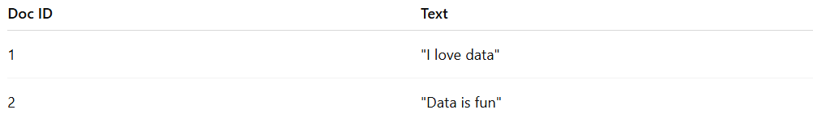
Doc ID | Text
1 | "I love data"
2 | "Data is fun"
Vocabulary: ["I", "love", "data", "is", "fun"]
One-Hot Encoding representation:
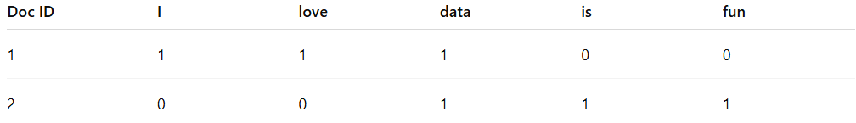
Doc ID | I | love | data | is | fun
1 | 1 | 1 | 1 | 0 | 0
2 | 0 | 0 | 1 | 1 | 1

Applications
# Source: AI Source: Provided by: [Data Path: Persons Table -> ID Column: 1, Name_En Column: Motasem Essam] -> From: [ChatGPT] on [12/10/2025]
- Text classification (spam detection, sentiment analysis)
- Machine learning models that require numerical input
- Feature representation for small text datasets

Advantages
# Source: AI Source: Provided by: [Data Path: Persons Table -> ID Column: 1, Name_En Column: Motasem Essam] -> From: [ChatGPT] on [12/10/2025]
- Simple and easy to implement
- Preserves exact presence or absence of words
- Works well for small vocabularies

Disadvantages
# Source: AI Source: Provided by: [Data Path: Persons Table -> ID Column: 1, Name_En Column: Motasem Essam] -> From: [ChatGPT] on [12/10/2025]
- Creates high-dimensional sparse vectors for large vocabularies
- Ignores word order and context
- Not suitable for large corpora or complex NLP tasks

